Experiment - 1

Consider following databases and draw ER diagram and convert entities
and relationships to relation table for a given scenario:
COLLEGE DATABASE:
STUDENT (USN, SName, Address, Phone, Gender)
SEMSEC (SSID, Sem, Sec)
CLASS (USN, SSID)
SUBJECT (Subcode, Title, Sem, Credits)
IAMARKS (USN, Subcode, SSID, Test1, Test2, Test3, FinalIA)

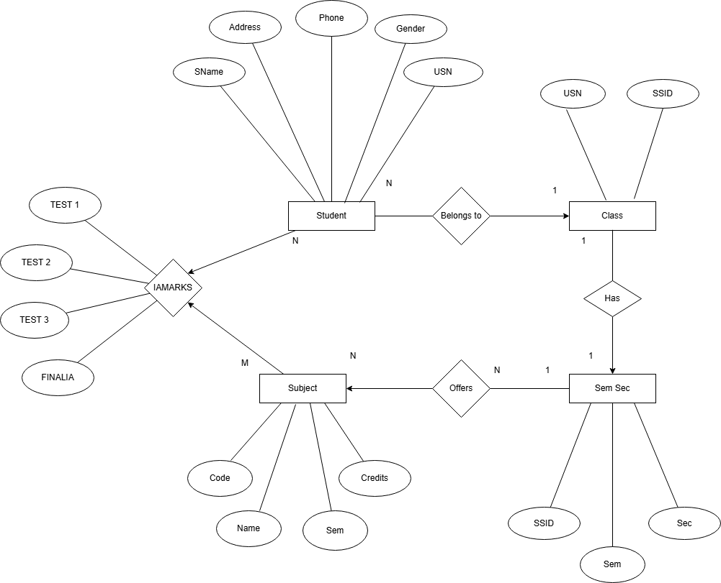
ER diagram for a College Database to represent how different academic data is organized and related.
STUDENT entity stores student details like USN, name, address, phone, and gender.
SEMSEC entity represents semester and section information using SSID.
CLASS is a relationship that connects STUDENT and SEMSEC, showing which student belongs to which semester and section.
SUBJECT entity stores subject details such as subject code, title, semester, and credits.
IAMARKS entity records internal assessment marks of students for each subject, including Test1, Test2, Test3, and Final IA marks. It connects STUDENT, SUBJECT, and SEMSEC using keys like USN, Subcode, and SSID.

Experiment - 2

Consider following databases and draw ER diagram and convert entities
and relationships to relation table for a given scenario:
COMPANY DATABASE:
EMPLOYEE (SSN, Name, Address, Sex, Salary, SuperSSN, DNo)
DEPARTMENT (DNo, DName, MgrSSN, MgrStartDate)
DLOCATION (DNo,DLoc)
PROJECT (PNo, PName, PLocation, DNo)
WORKS_ON (SSN, PNo, Hours)

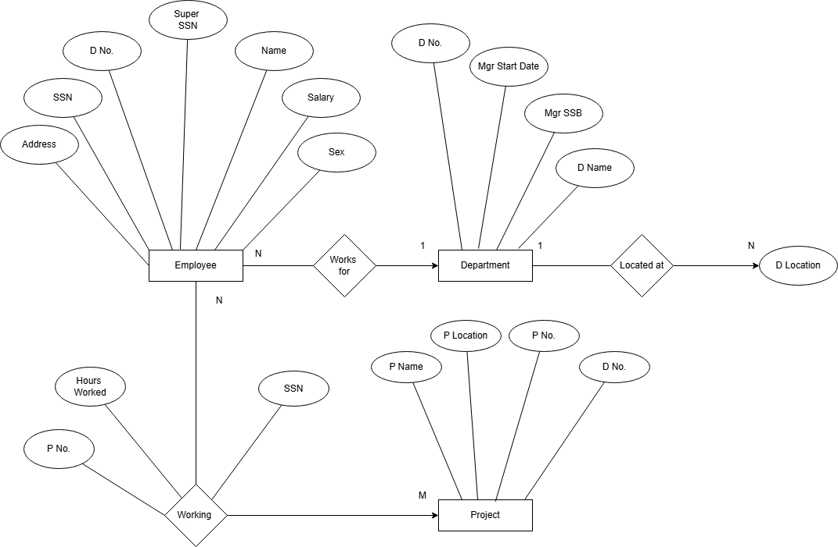
ER diagram for a Company Database to represent employees, departments, projects, and their relationships.
EMPLOYEE entity stores employee details such as SSN, name, address, sex, salary, supervisor SSN, and department number.
DEPARTMENT entity contains department information like department number, department name, manager SSN, and manager start date.
DLOCATION entity represents the different locations of each department.
PROJECT entity stores project details such as project number, project name, project location, and department number.
WORKS_ON is a relationship between EMPLOYEE and PROJECT that records how many hours an employee works on a project.
The ER diagram also shows relationships like employee supervision, employees working for departments, and departments controlling projects.

